Website Specifications
Objective and Goals
Objective: To establish Glotto Clothing as a recognizable fashion brand from Botswana, showcasing its collections, cultural heritage, and sustainable practices.
Goals:
-Promote Glotto Clothing’s identity and story as a Botswana-based fashion label.
-Display collections (Men’s Wear, Women’s Wear, Accessories) in a visually appealing way.
-Provide a lookbook to inspire customers with styled outfits.
-Highlight sustainability initiatives and community empowerment.
-Enable easy customer engagement through contact forms and social media integration.
-Build brand awareness both locally and internationally.

Target Audience
Demographics:
- Age: 18–40 (young adults and professionals interested in fashion).
-Gender: Male and female, with emphasis on inclusivity.
-Location: Primarily Botswana and Southern Africa, with international reach.
-Lifestyle: Fashion-conscious, culturally aware, eco-conscious consumers.
Technical Aptitude:
-Comfortable with browsing online stores and social media.
-Moderate to high digital literacy (smartphone and desktop users).
-Expect responsive, mobile-friendly design and fast-loading pages.
-Familiar with online shopping, Instagram lookbooks, and e-commerce platforms.

Type of Website / Content
Type:
Fashion Brand Website with portfolio-style presentation and optional e-commerce integration.
Content includes:
-Hero banner with brand tagline.
-About Us section (brand story, mission, values).
-Collections (product categories with images).
-Lookbook (styled gallery of outfits).
-Sustainability (eco-friendly practices and artisan stories).
-Contact (form + social media links).
-Footer with branding and legal links.
Content Style:
-Visual-first: high-quality images of clothing and models.
-Minimalist, modern layout with strong use of white space.
-Clear navigation and consistent branding.
-Engaging copy that emphasizes heritage, authenticity, and sustainability.

-
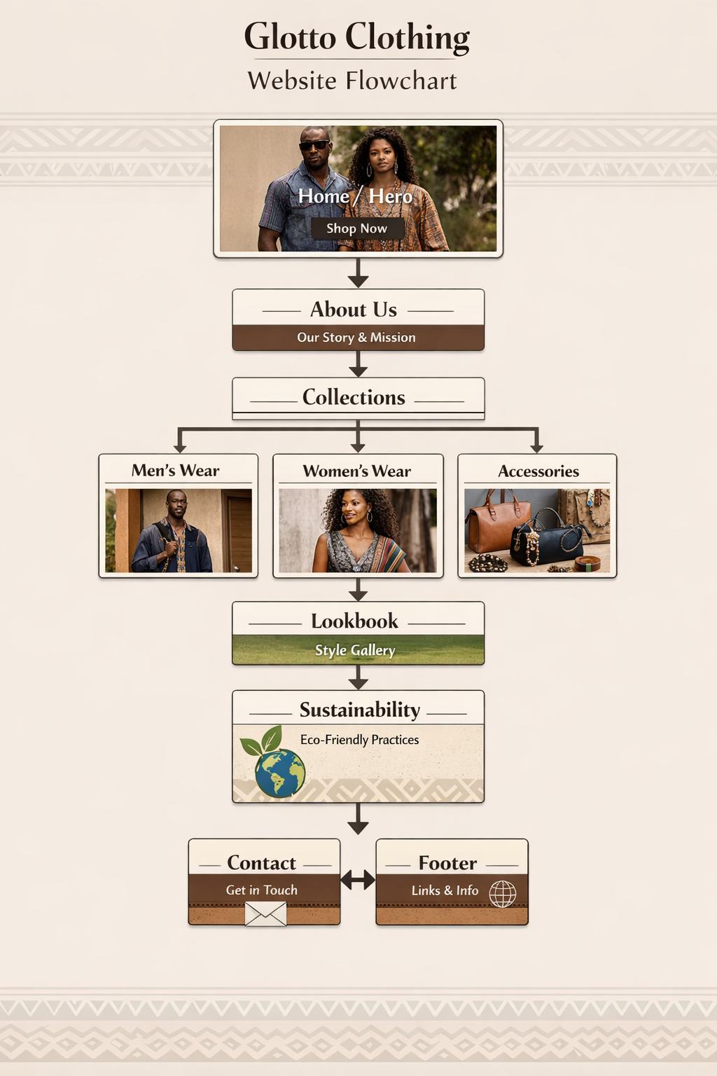
Contact

Lookbook
About
Sustainability
collections
Home
Glotto Clothing
Hero Image
Authentic Botswana Style, Global Appeal

About Us
Glotto is a design-led fashion house founded in Botswana. Inspired by the terracotta hues, sun-baked ochres, and mineral textures of the Sub-Saharan landscape, our garments embody the spirit of the evolved hunter-gatherer: ever-glowing, ever-growing, seeking knowledge while carrying inherited lessons.
Glotto is derived from the word glottology; the study of languages, signifying how each piece speaks a universal tongue that transcends borders. Conceived as wearable archives, Glotto garments are crafted through a community-based value chain that balances cultural preservation with innovation. Each collection is unveiled through story-driven campaigns, presenting pieces with memory, depth, and intention beyond the season.
Vision
To shift global perceptions of African design through intentional clothing rooted in culture, community, and craftsmanship.
Mission
To create seasonless, genderless garments that preserve identity, empower artisans, and reimagine Botswana as a source of design innovation.

Shop Now

Gallery image

Gallery image

Gallery image
Lookbook
Style Inspiration
View more
Accessories

Product image
View more
Womens Wear
Product image
View more
Mens Wear
Product image
Our Collections

Gallery image
Gallery image
Eco icon

Contact form

Get in Touch

Sustainability
Our Eco-Friendly Practices
We use locally sourced fabrics and natural fibers that minimize environmental impact. Our production process focuses on reducing waste, reusing materials, and promoting long-lasting quality over fast fashion trends.

Send
Message
Email
Name
Contact
Get in Touch

